**PREDICTION OF PERSONAL LOAN APPROVAL USING MACHINE LEARNING**

**INTRODUCTION**

**OVERVIEW**

A loan is the core business part of banks. The main portion the bank’s profit is directly come from the profit earned from the loans. Though bank approves loan after a regress process of verification and testimonial but still there's no surety whether the chosen hopeful is the right hopeful or not. This process takes fresh time while doing it manually. We can prophesy whether that particular hopeful is safe or not and the whole process of testimonial is automated by machine literacy style. Loan Prognostic is really helpful for retainer of banks as well as for the hopeful also

**PURPOSE**

When you fill out a loan application, you may come across a section that asks you to specify the purpose of the loan. Some lenders do this to give you the right product. They may also use your loan objective to assess risk and specify loan terms.There are several reasons you might consider taking out a Personal Loan. Most people have something special on their minds when they decide to borrow money. Three out of every four people considering taking out a  Personal Loan say the decision is driven by a specific upcoming need or life event

**PROBLEM DEFINITION** **& DESIGN THINKING**

**EMPATHY MAP**

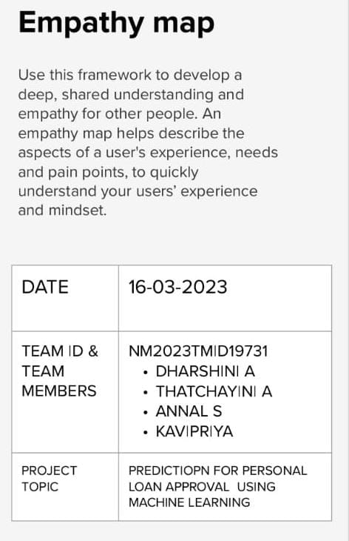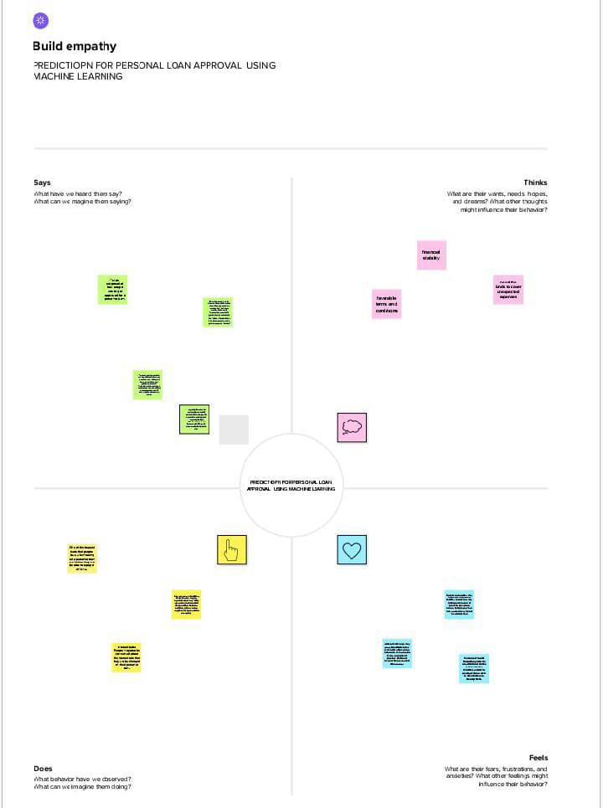

**IDEATION & BRAINSTORMING MAP**

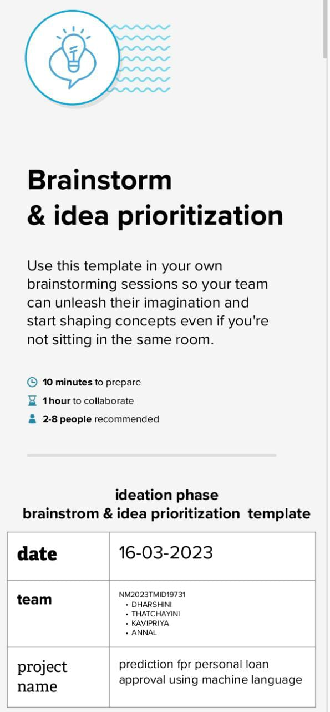 

• Time period for loan anctioning will be reduced. • Whole process will be automated , so human error will be avoided

• Eligible applicant will be sanctioned loan without any d

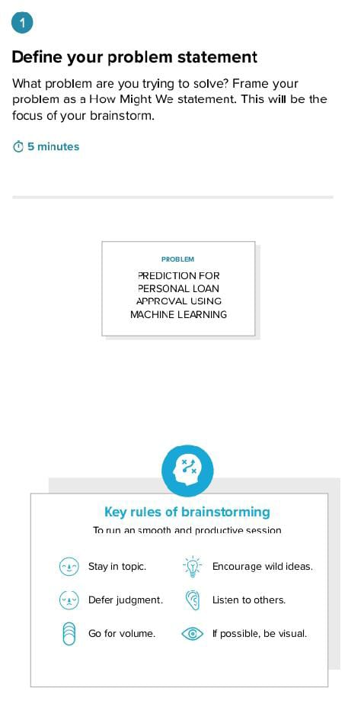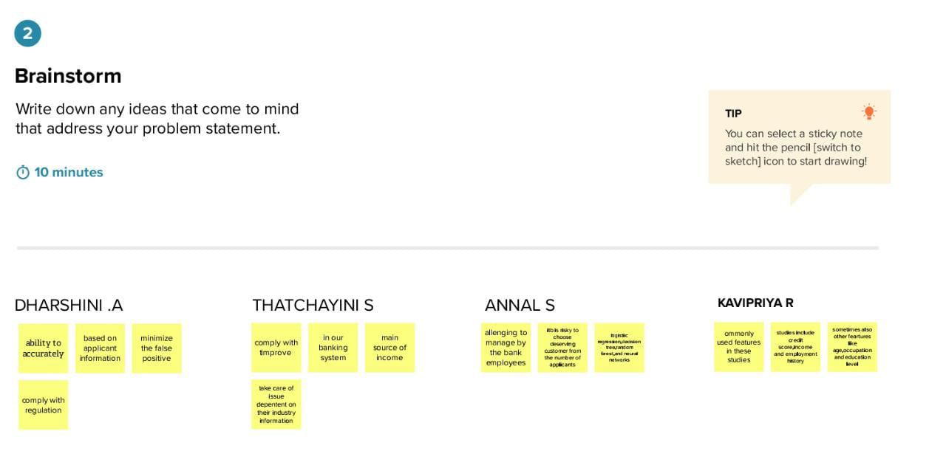

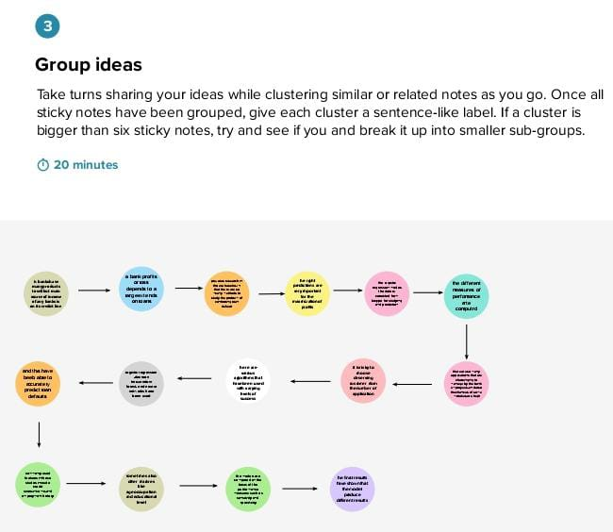

**RESULT**

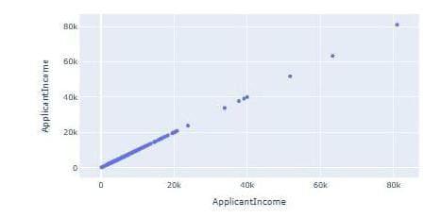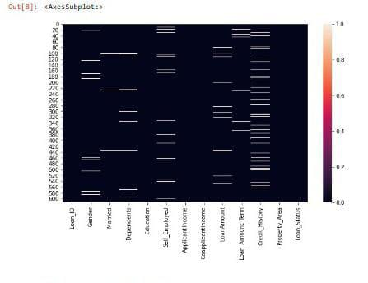

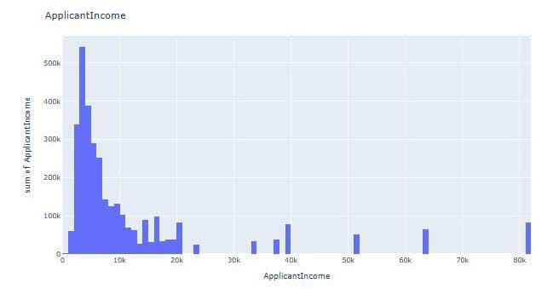

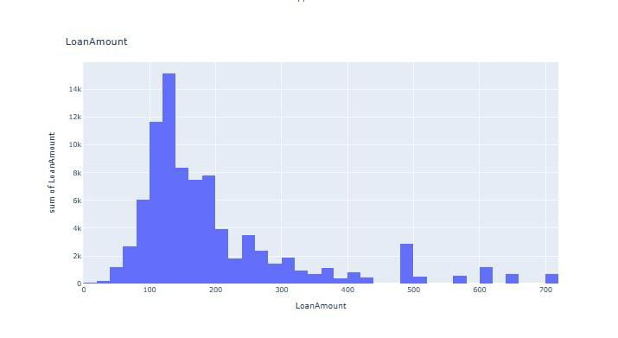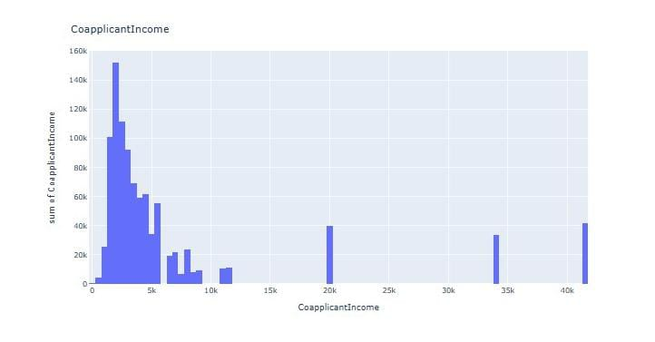

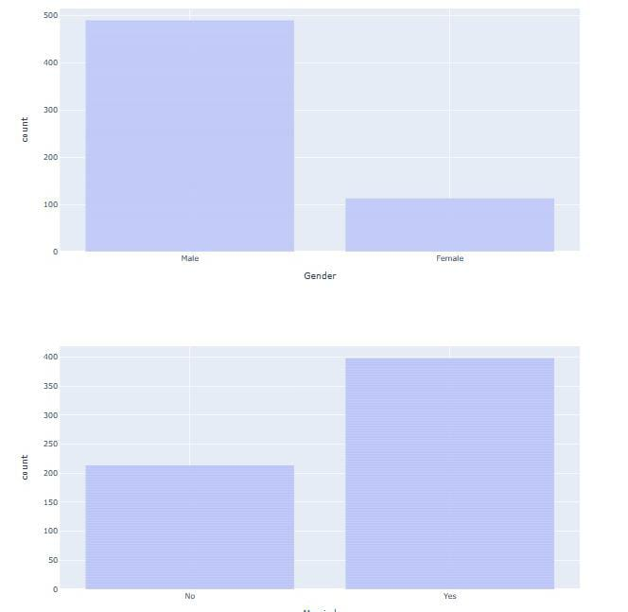

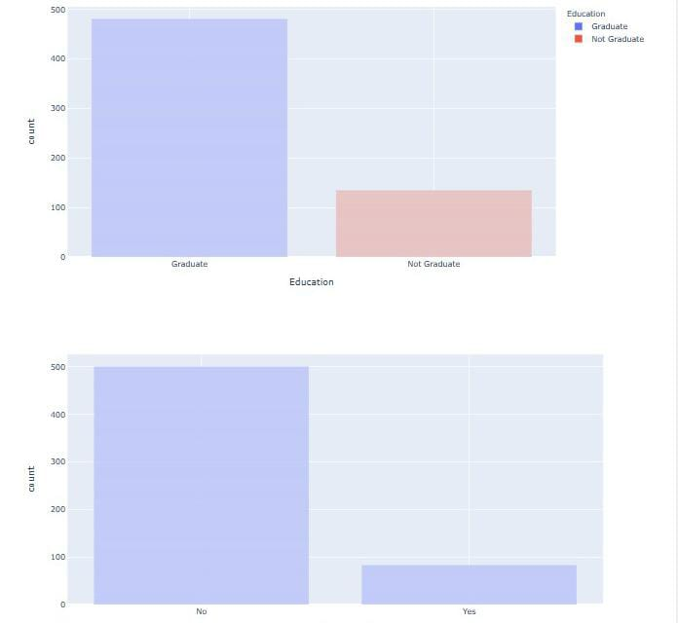

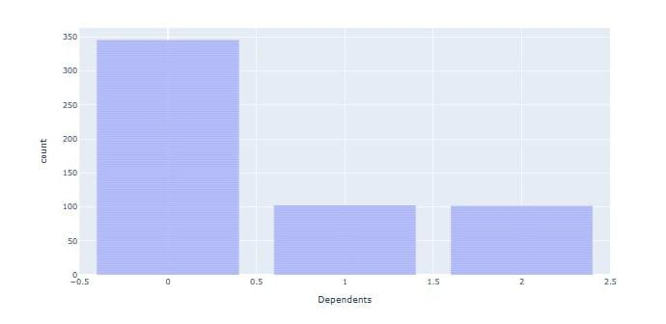

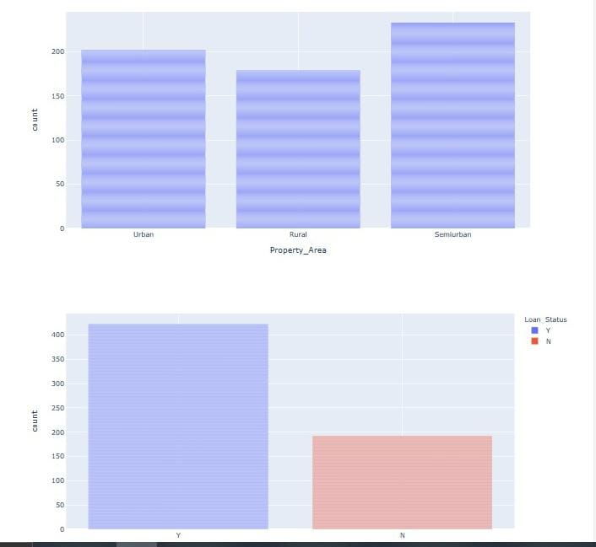

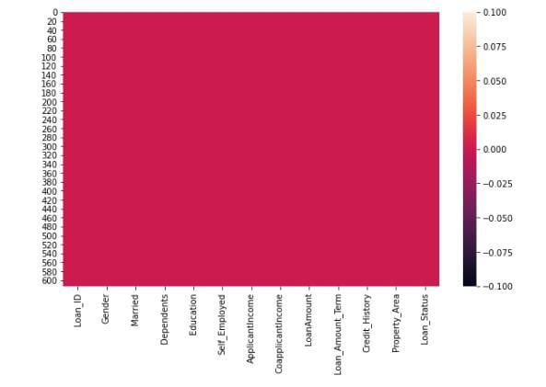

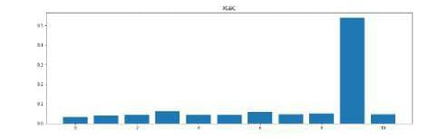

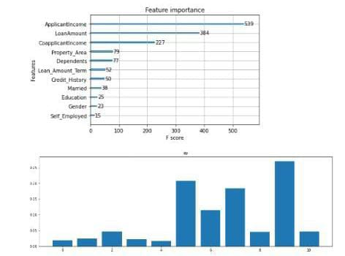

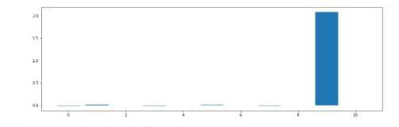

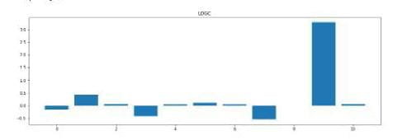

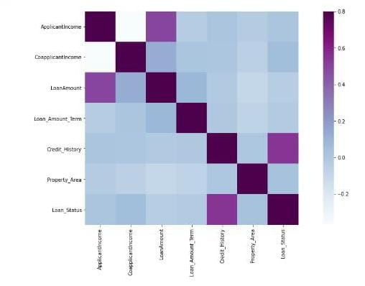

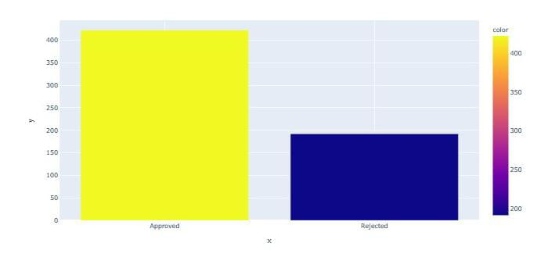

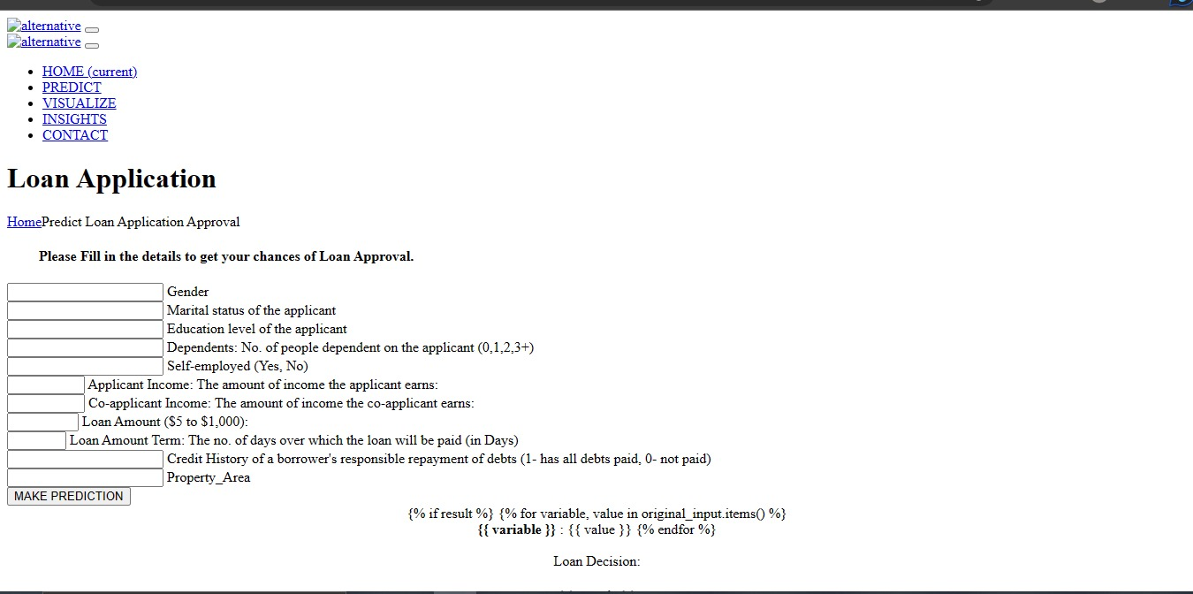

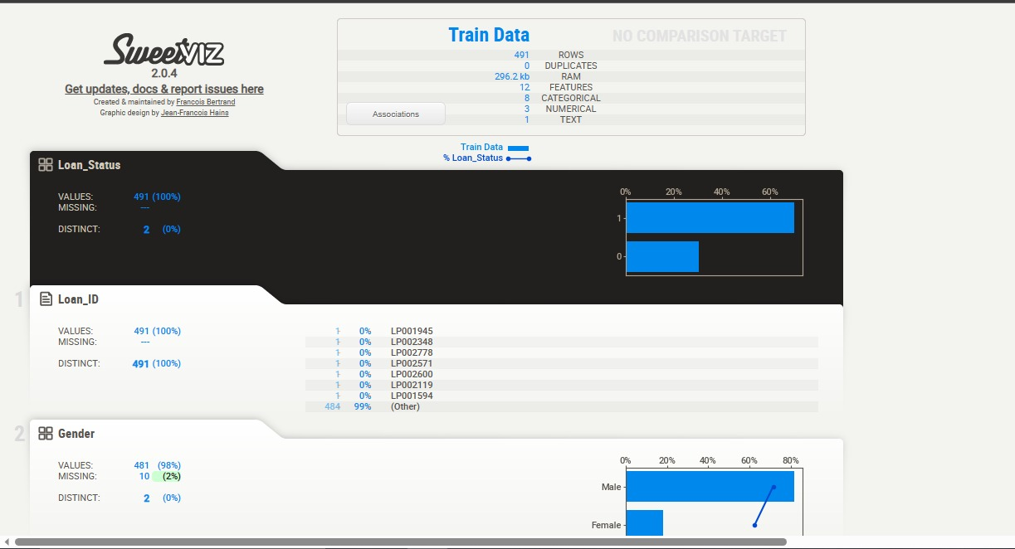

**ADVANTAGES & DISADVANTAGES**

**ADVANTAGES**

**The Loan Prediction System can can automatically calculate the weight of each features taking part in loan processing and on new test data same features are processed with respect to their associated weight . A time limit can be set for the applicant to check whether his/her loan can be sanctioned or not.**

**It is done by predicting if the loan can be given to that person on the basis of various parameters like credit score, income, age, marital status, gender, etc. The prediction model not only helps the applicant but also helps the bank by minimizing the risk and reducing the number of defaulters**

**Accuracy—one of the primary benefits of using machine learning for credit scoring is its accuracy. Unlike human manual processing, ML-based models are automated and less likely to make mistakes. This means that loan processing becomes not only faster but more accurate, too, cutting costs on the whole.**

**DISADVANTAGES**

**The disadvantage of this model is that it emphasize different weights to each factor but in real life sometime loan can be approved on the basis of single strong factor only, which is not possible through this system. Loan Prediction is very helpful for employee of banks as well as for the applicant also.**

**1.cons of personal loan**

**2.Interest rates can be higher than alternatives.**

**3.More eligibility requirements.**

**4.Fees and penalties can be high.**

**5.Additional monthly payment.**

**6.Increased debt load.**

**7.Higher payments than credit cards.**

**8.Potential credit damage**

**APPLICATION**

**Personal loans are borrowed money that can be used for large purchases, debt consolidation, emergency expenses and much more. These loans are paid back in monthly installments over the course of a few months or upwards of a few years. It can take longer depending on your circumstances and how diligent you are with making payments.**

**In some cases, you might want to try something else before taking out a personal loan, like a small purchase or negotiating a lower price or cost.**

**\*Personal loans are loans that can cover a number of personal expenses.**

**\*You can find personal loans through banks, credit unions, and online lenders.**

**with no collateral needed.**

**\*Personal loans can vary greatly when it comes to their interest rates, fees, amounts, and repayment terms.**

**CONCLUSION**

**From a proper analysis of positive points and constraints on the member, it can be safely concluded that the product is a considerably productive member. This use is working duly and meeting to all Banker requisites. This member can be freely plugged in numerous other systems. There have been mathematics cases of computer glitches, violations in content and most important weight of features is fixed in automated prophecy system, so in the near future the so – called software could be made more secure, trustworthy and dynamic weight conformation. In near future this module of prophecy can be integrated with the module of automated processing system. The system is trained on old training dataset in future software can be made resembling that new testing date should also take part in training data after some fix time.**

**FUTURE SCOPE**

**This project work can be extended to higher level in future.for example,A predivtive model for loans that uses machine learning algorithms,where the result from each graph of the project can be taken as individual criteria for the machine learning algorithm can be created also,A risk score can be generated based on applicant to predict loan default rate**

**APPENDIX**

**A.Source code**

